1. Which of the following quantities has a unit that can be expressed in terms of the just two different SI base units?
A. area B. charge C. current D. force

2. In a simple electrical circuit, the current in a resistor is measured as (2.50 ± 0.05) mA. The resistor is marked as having a value of 4.7Ω ± 2%.
If these values were used to calculate the power dissipated in the resistor, what would be the percentage uncertainty in the value obtained?
A. 2% B.4% C. 6% D. 8%

3. A spacecraft is descending to the Moon's surface at a steady velocity of 2.0 ms⁻¹. At a height of 4.0 m the engines are cut off and it falls freely to the surface. Taking Moon's gravitational acceleration as 1.6ms⁻¹, at what speed, in ms⁻¹, does it strike the Moon?
A. 3.6 B. 4.1 C. 12.8 D. 14.8

4. A student can walk up a stationary escalator in 90s. Standing on the escalator when it is moving, the student goes up in 60s. How long would it take the student to walk up the moving escalator?
A. 24s B. 30s C. 36s D.75s

5. The driver of a car has a mass of 80kg. When the car brakes sharply the deceleration of the car and driver is 2.5ms⁻². The size of the total force exerted by the car seat and safety belt on the driver during braking is
(Take g = 10 ms⁻²)
A. 200N B. 600N C. 825N D. 1000N

6. Two forces, 20 N and 10 N, act at a point Q as shown in the diagram. The angle between the directions of the forces is 120º.
20N
120º
10N
Q

What is the magnitude of the resultant force?

A. 10 N B. 17 N C. 22 N D. 26 N

- A projectile is fired at an angle α to the horizontal at a speed u as shown.

u
α

What will be the vertical and horizontal components of its velocity after a time t?
Assume that air resistance is negligible. The acceleration of free fall is g.

 | Vertical component | Horizontal component
A. | u sin α | u cos α
B. | u sin α -gt | u cos α -gt
C. | u sin α -gt | u cos α
D. | u cos α | u sin α -gt

- A small steel sphere is released from rest at a height, h above the ground level. Which of the following graphs most closely represents the variation of kinetic energy of the sphere, E_{k} with the distance it moves, x? (Ignore the air resistance)

x
E_{k}
A.
h
x
E_{k}
B.
h
x
E_{k}
C.
h
x
E_{k}
D.
h

9. A uniform plank of weight 60N is 200 cm long and rests on a support that is 60 cm from end E. A load of 10 N is tied to another end of the plank with a rope that runs through a frictionless pulley. At what distance from E must a 50 N weight be placed in order to balance the plank?
40
10N
E
120
80
160
200

A. 20 cm B. 40 cm C. 50 cm D. 76 cm

10. For inelastic collision, which are the quantities that are conserved?

- Total momentum and total energy of the system.
- Total momentum and total kinetic energy of the system.
- Total kinetic energy and total energy of the system.
- Total momentum, total kinetic energy and total energy of the system.

11.
R
P
60º
A
B

The figure above shows body A and body B in equilibrium. Given that the tension in the string PR is T, the weight of body B is W and the friction between body A and the rough surface is R, which list gives the three forces in increasing order of magnitude?

A. T,W,R B. T,R,W C. W,R,T D. R,T,W

a
M₁
M₂

12

An engine of mass M₂ is pulling a truck of mass M₁, the acceleration of the system being a. The engine exerts a tractive force F and the truck and the engine are both subjected to effective resistances R₁ and R₂ respectively. The tension in the coupling between the engine and truck is T. Which of the following equation is incorrect?

- F – T – R₂ = M₂a
- T – R₁ = M₁a
- F – R₁ – R₂ = (M₁ + M₂)a
- F = (M₁ + M₂)a

13. A crane has a maximum safe working load of 1200 kg and is used to lift a concrete block of mass 1000 kg. What is the maximum safe upward acceleration of the block whilst being lifted?

- 0.19 ms⁻²
- 0.85 ms⁻²
- 1.52 ms⁻²
- 1.96 ms⁻²

14. Which one of the followings has different base units from the others?

- Stress x Strain
- Stress/Strain
- Torque
- Potential energy per unit volume

15. A small car of mass 800 kg, is being driven in foggy condition. In this situation the maximum deceleration of the car is 7.5 ms⁻². While driving at the constant speed of 21 ms⁻¹, the driver sees a stationary car 30 m ahead and takes 0.40 s to react. Determine the speed at which the car will hit the stationary car.

A. 3.0 ms⁻¹ B. 5.2 ms⁻¹ C. 10.8 ms⁻¹ D. 12.3 ms⁻¹

16. In an experiment to demonstrate Brownian motion in a gas, a brightly illuminated cell containing smoke is viewed under a microscope. The observer sees a large number of bright specks undergoing random motion. Which one of the following statements about this experiment is correct?

- Light is being scattered by gas molecules.
- The larger the smoke particle, the greater is the speed of the bright specks.
- The lower the smoke pressure of the gas, the more frequent are the direction changes of the bright specks
- The higher the temperature of the gas, the faster is the motion of the bright specks.

17. The densities of water and steam are 1.0 ×10³kgm⁻³ and 6.1 ×10⁻¹kgm⁻³ respectively. What is the ratio average separation of steam molecules ?
average separation of water molecules

A. 12
B. 40
C. 250
D. 1600

18. An incompressible liquid of density ρ is contained in a vessel of uniform cross-sectional area A. If the atmospheric pressure is p, then the force acting on a horizontal plane of area a situated at a depth d in the liquid is given by

- Ap + adρg
- p/A + dρg/a
- (p + dρg)/a
- a(dρg + p)

19. Which statement concerning the evaporation and boiling of a liquid is true?
- Boiling always occurs at a higher temperature than evaporation.
- Evaporation and boiling are unaffected by changes in the surface of the liquid.
- Evaporation occurs at any temperature whereas the boiling point depends on the external pressure.
- Evaporation results in the loss of the most energetic molecules from a liquid whereas in boiling, all molecules have the same energy.

20. The figure 4 represents a uniformly tapering vessel which is completely full of a liquid of density 800 kgm⁻³.
0.20m
area 2.0 x 10⁻⁴ m²
area 1.0 x 10⁻⁴ m²

Figure 4

What is the thrust on the base of the vessel due to the liquid?
A. 0.16N B. 0.20N C. 0.24N D. 0.28N
- A wire is stretched by a force F which causes an extension l. The energy stored in the wire is Fl only if

  - the extension of the wire is proportional to the force applied.
  - the weight of the wire is negligible.
  - the wire is not stretched beyond its elastic limit.
  - The acceleration of free fall is constant.

- A spring obeying Hooke’s law has an unstretched length of 40 mm and a spring constant of 500 Nm⁻¹.
What is the tension in the spring when its overall length is 70 mm?

A. 1.5 N B. 15 N C. 3.5 N D. 35 N

    - A steel wire of diameter d is found to have a strain of 1.0 x 10⁻⁴ when supporting a certain load. This wire is replaced by a second wire of the same material and of the same length but of diameter 0.5 d.
What is the strain when the second wire supports the same load, assuming that neither wire exceeds its elastic limit?

A. 8.0 x 10⁻⁴ B. 4.0 x 10⁻⁴ C. 2.0 x 10⁻⁴ D. 5.0 x 10⁻⁵

- Visible light has wavelengths between 400 nm and 700 nm, and its speed in a vacuum is 3.0 x 10⁸ ms⁻¹. What is the maximum frequency of visible light?

A. 1.2 x 10¹¹ Hz B. 4.3 x 10¹¹ Hz C. 4.3 x 10¹⁴ Hz D. 7.5 x 10¹⁴ Hz

25. A sound wave of amplitude 0.20 mm has an intensity of 3.0 W m⁻². What will be the intensity of a sound wave of the same frequency which has an amplitude of 0.40 mm?

A 4.2 W m⁻² B 9.0 W m⁻²

C 6.0 W m⁻² D 12 W m⁻²

26. The principle of superposition states that

A. the total displacement due to several waves is the sum of the displacements due to those waves acting individually.
B. two stationary waves superimpose to give two progressive waves.
C. a diffraction pattern consists of many interference patterns superimposed on one another.
D. two progressive waves superimpose to give a stationary wave.
27. When monochromatic light of wavelength 5.0 x 10⁻⁷ m is incident normally on a plane diffraction grating, the second order diffraction line are formed at angles of 30º to the normal to the grating.
What is the number of lines per millimeter of the grating?

A. 250 B. 500 C. 1000 D. 2000

- A stationary wave is set up on a stretched string XY as shown in the diagram.

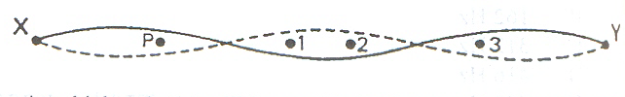
At which point(s) will the oscillation be in phase with that at P?

A. 3 only
- 2 and 3 only
- 1 and 2 only
- 1, 2 and 3

29. Two large horizontal metal plates are separated by 2 mm. The lower plate is at a potential of –6V.

- 6V
2 mm

What potential should be applied to the upper plate to create an electric field of strength 2000 Vm⁻¹ upwards in the space between the plates?

A. +22 V C. -10 V

B. +10 V D. -2 V

30. A rod is to be drawn from a 100 cm³ of metal of resistivity 1.76 10⁻⁸ Ωm. What is the cross sectional area of the rod if the resistance of the rod is to be 7.0 10⁻⁴Ω?

A. 2.5 10⁻⁹ m² B. 4.7 × 10⁻⁹ m²

C. 5.0 10⁻⁵ m² D. 6.3 10⁻⁵ m²

- In the circuit shown below, the resistance of the tungsten filament lamp L increases with temperature. The current can be varied by means of a rheostat.

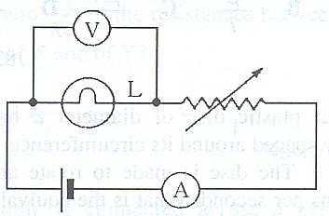

Which one of the following graphs best shows how the ammeter reading I varies with the voltmeter reading V?

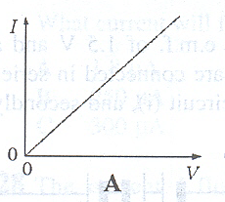 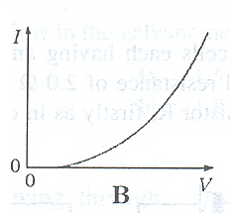`

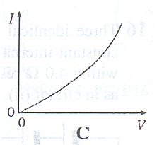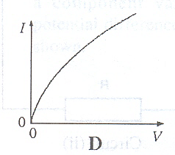

- The diagram shows the relation between the direct current I in a certain conductor and the potential difference V across it. When V < 1.8 V, the current is negligible.

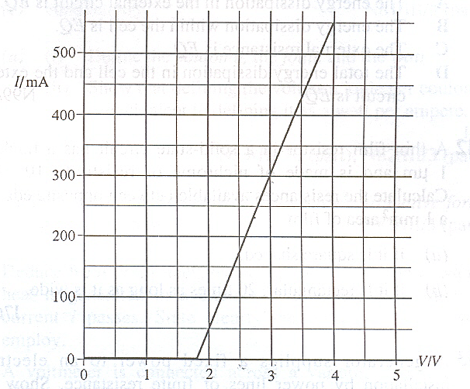

Which statement about the conductor is correct?

- It does not obey Ohm’s law but when V > 1.8 V, its resistance is 4 Ω.
- It does not obey Ohm’s law but when V = 3 V, its resistance is 10 Ω.
- It obeys Ohm’s law when V > 1.8 V and when V = 3 V, its resistance is 10 Ω.
- It obeys Ohm’s law when V > 1.8 V but its resistance is not constant.

33. In the diagram, what is the resistance between M and N?

. M

6Ω 10Ω

6Ω

10Ω

N

A. 4 Ω B. 8 Ω C. 16 Ω D. 32 Ω

34. The diagram shows a circuit for measuring a small e.m.f. produced by a thermocouple.

2.00 V R

2.00 Ω

+
-

thermocouple galvanometer
6.00 mV

There is zero current in the galvanometer when variable resistor is set at 3.0 Ω. What is the value of resistance R ?

A. 195 Ω B. 495 Ω C. 995 Ω D. 1995 Ω

35. Which diagram shows the electric field pattern of an isolated positive point charge?

+
+
+
+

A. B. C. D

36. Light of wavelength λ is incident normally on a diffraction grating for which the slit spacing is equal to 3λ.
What is the sine of the angle between the second order maximum and the normal?

A.  B. C.  D. 1

37. Which statement describes the electric potential difference between two points in a wire that carries a current?

A. it is the force required to move a unit positive charge between the points
B. it is the ratio of the energy dissipated between the points to the currents
C. it is the ratio of the power dissipated between the points to the current
D. it is the ratio of the power dissipated between the points to the charge moved

38. In an experiment on α-particle scattering, α-particles are directed towards a gold foil, and detectors are placed at positions P, Q and R in the diagram.

P gold foil Q

α R

What is the distribution of α-particles as recorded at P, Q and R respectively?

 | P | Q | R
A  B  C  D | None  None  Most  few | None  Some  Some  some | All  None  Few  most

39. A radioactive source is placed in front of a G-M tube connected to a counter. Various absorbers are placed between the source and the G-M tube and the count-rate recorded. The following results were obtained.

Absorber | Count/min⁻¹
No absorber  A sheet of paper  5 mm thick aluminium sheet  25 mm thick lead block | 711  502  492  218

It can be deduced from these results that the radiations emitted by source is/are

A. β-rays only B. α-,β- and γ rays C. α- and γ rays only D. β- and γ rays

40. The isotope which decays by  - emission to produce 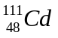 is

A. 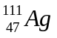 B. 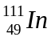

C . 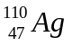 D. 